

Direct (410) 535-9060

Office (410) 535-6291

[sallyshowalter@comcast.net](mailto:sallyshowalter@comcast.net)

**Sally LD Showalter – GRI, ACP**

**RE/MAX One**



RE/MAX One

*www.sallyshowalter.remaxagent.com*

Main St

132

Prince Frederick, MD 20678

Each office independently owned and operated.

©2017 Imprev, Inc. Pub 12/17

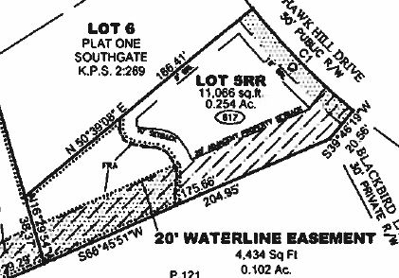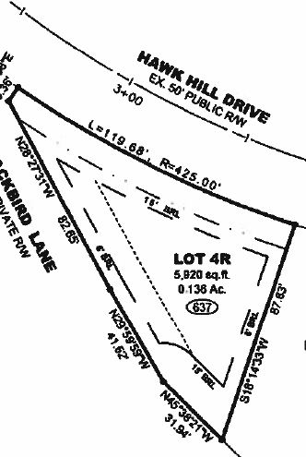

Building site in 55+ community right in the heart of Prince Frederick. Foundation in place, tap fees have been paid. Previous building permit, but will need to be updated. Two other remaining lots in Southgate are also available. Ideal for builder who wants to complete this community. Also, Perfect for the person who wants to downsize and have less outside maintenance. Build an open concept home with main level bedrooms, simplify life!! Recorded plats available. Great neighbors, great location convenient to shopping, library, hospital, aquatic center, restaurants.

**617 Hawk Hill Drive**

**$75,000**

**637 Hawk Hill Drive**

**$70,000**